**Setting up agent through master Jenkins , explaining keywords and many more!!**

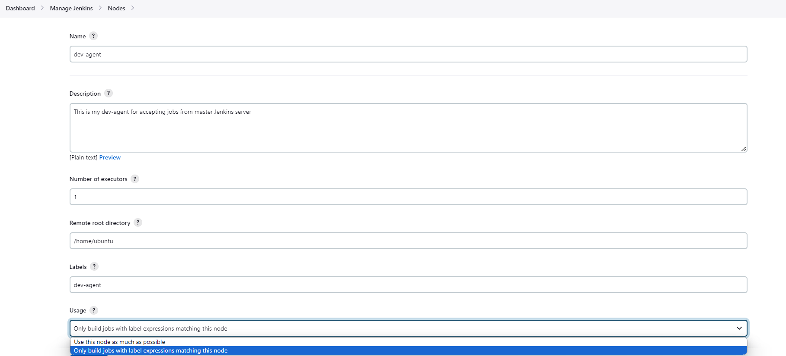

**Description**: Give description as it will help anyone to understand what this agent is capable of !!

Keep **No. of executors as 1**

**Remote Host Directory**: It is used to set working directory for your Host(agent server) where your Jenkins workspace will be created.

**Labels**: It is important to give label to your agent as It will be useful during declarative pipeline !

**Usage**: When to use this agent? We have 2 options in dropdown ( choose appropriate , We are choosing 2nd as we want to use this agent only if it is mentioned in my pipeline).

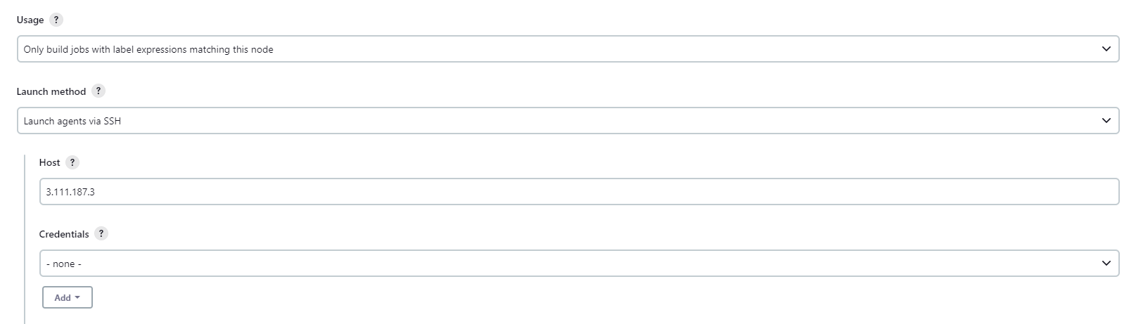

Now put your agent server public Ip address in host. Our master wants to give job to agent so we will put agent’s public IP address.

Lets set credentials as we don’t have !

Click on Add > Click on Jenkins

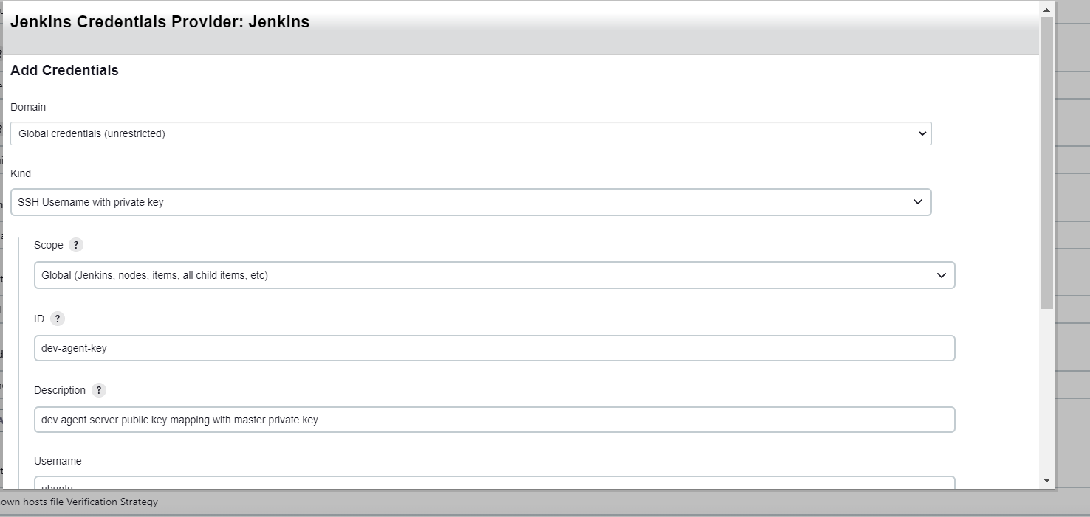

**Kind**: SSH username with private key

**ID**: can be anything , you name it but understandable

**Description**: again your choice but understandable

**Username**: ubuntu (can be anything but keep ubuntu for now equivalent to agent server ..type whoami on agent server you will get logged in user and put it here)

Now ,

Lets go to our master server and under .shh directory , take id_rsa that is our private key and copy-paste under private key on dashboard..

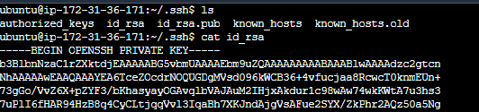

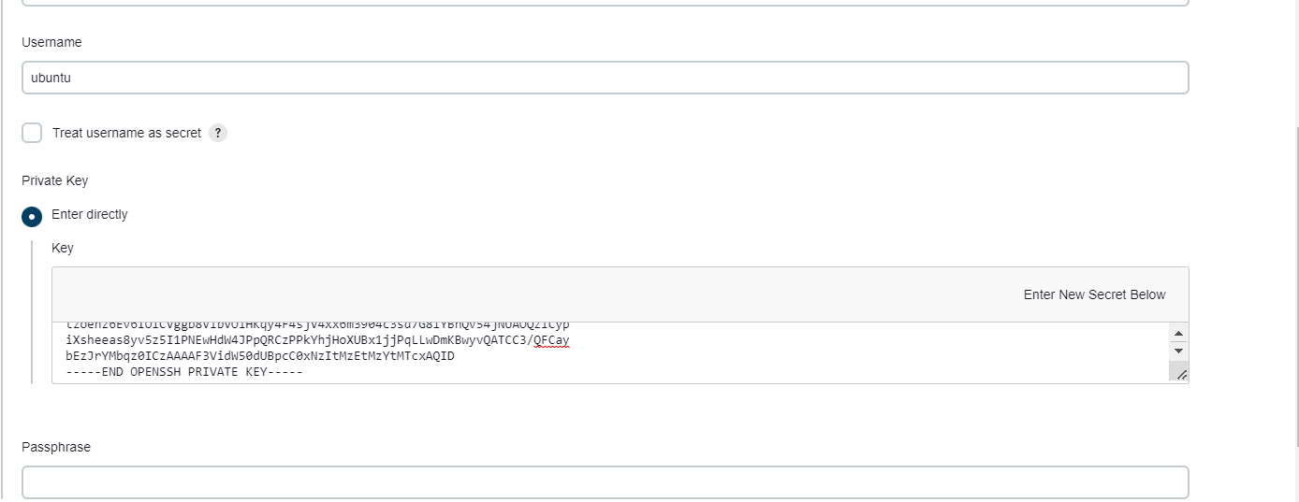

Now once added , go to host key verification strategy and select below option from drop down.

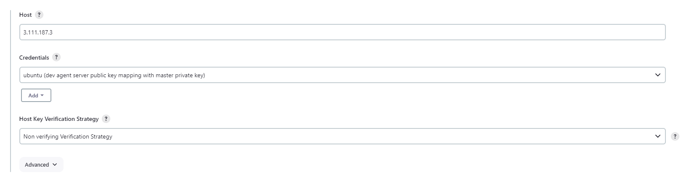

Then click on save with last option as **keep this agent as online as possible**